Chapter 0: Introduction

Pages
From page 17/737 To 37/737

Contents

0.1 The Role of Algorithms - Page 19

0.2 The History of Computing - Page 21

0.3 An Outline of Our Study - Page 26

0.4 The Overarching Themes of Computer Science - Page 28

- Algorithms
- Abstraction
- Creativity
- Data
- Programming
- Internet
- Impact

Figures

Figure 0.1 - Page: 20
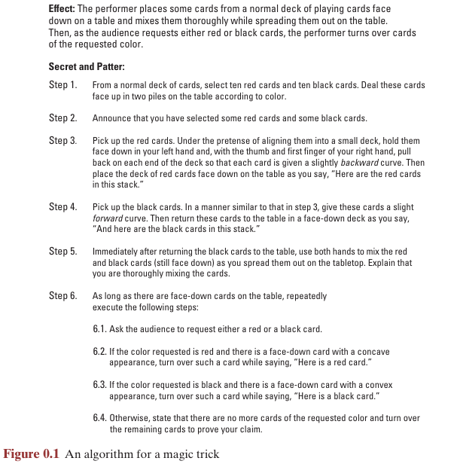

Figure 0.2 - Page: 20
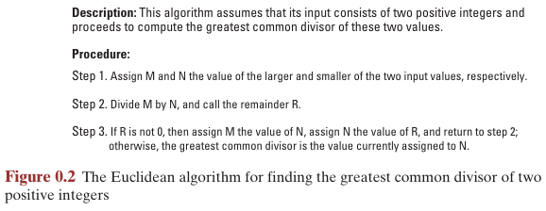

Figure 0.3 - Page: 21


Figure 0.4 - Page 23
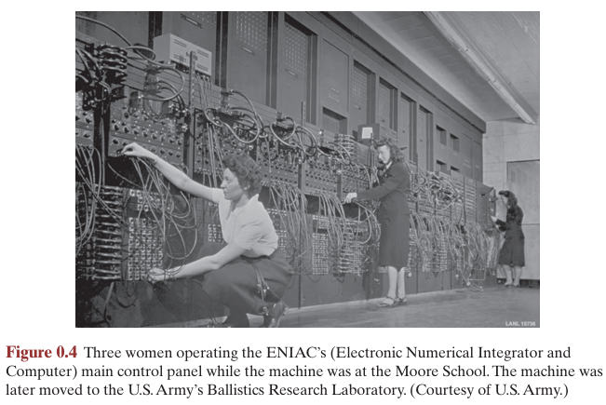

Figure 0.5 - Page 30
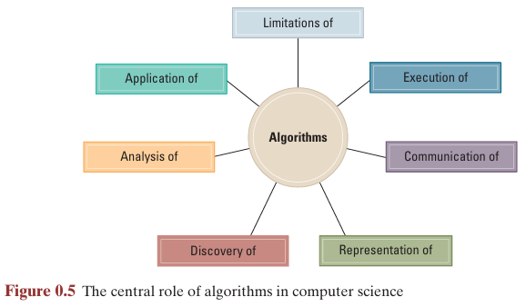

Descriptions

Babbage’s Difference Engine - Page: 24
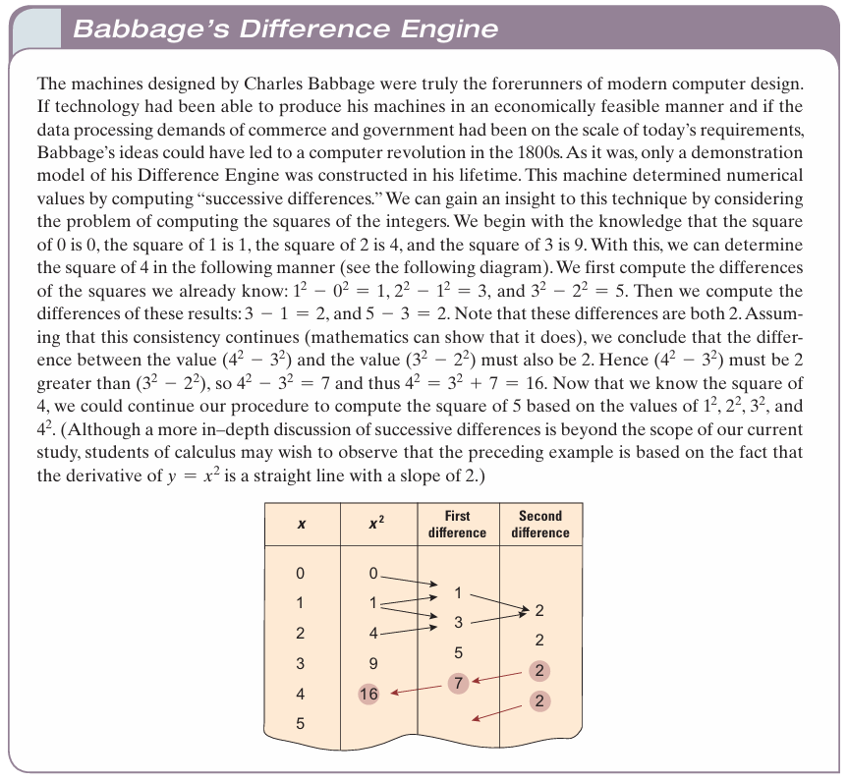

Augusta Ada Byron - Page: 25
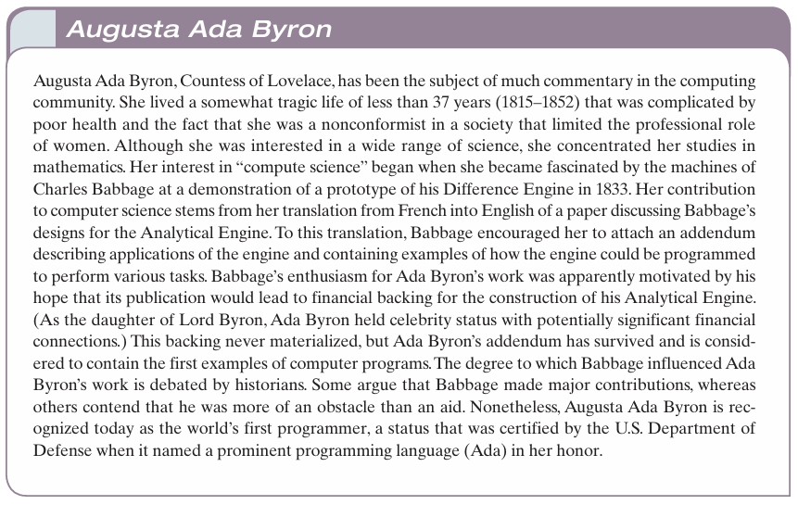

Google - Page: 26
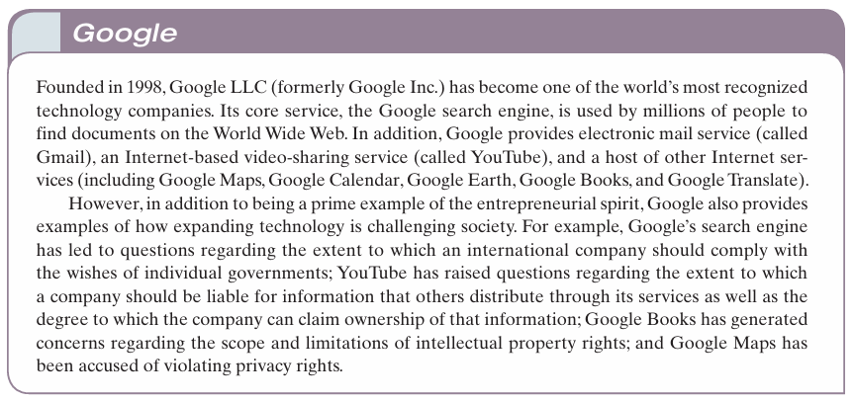

Social Issues - Page 35:36
The following questions are intended as a guide to the ethical/social/legal issues associated with the field of computing. The goal is not merely to answer these questions. You should also consider why you answered as you did and whether your justifications are consistent from one question to the next.

1. The premise that our society is different from what it would have been without the computer revolution is generally accepted. Is our society better than it would have been without the revolution? Is our society worse? Would your answer differ if your position within society were different?

2. Is it acceptable to participate in today’s technical society without making an effort to understand the basics of that technology? For instance, do members of a democracy, whose votes often determine how technology will be supported and used, have an obligation to try to understand that technology? Does your answer depend on which technology is being considered? For example, is your answer the same when considering nuclear technology as when considering computer technology?

3. By using cash in financial transactions, individuals have traditionally had the option to manage their financial affairs without service charges. However, as more of our economy is becoming automated, financial institutions are implementing service charges for access to these automated systems. Is there a point at which these charges unfairly restrict an individual’s access to the economy? For example, suppose an employer pays employees only by check, and all financial institutions were to place a service charge on check cashing and depositing. Would the employees be unfairly treated? What if an employer insists on paying only via direct deposit?

4. In the context of interactive television, to what extent should a company be allowed to retrieve information from children (perhaps via an interactive game format)? For example, should a company be allowed to obtain a child’s report on his or her parents’ buying patterns? What about information about the child?

5. To what extent should a government regulate computer technology and its applications? Consider, for example, the issues mentioned in Questions 3 and 4. What justifies governmental regulation?

6. To what extent will our decisions regarding technology in general, and computer technology in particular, affect future generations?

7. As technology advances, our educational system is constantly challenged to reconsider the level of abstraction at which topics are presented. Many questions take the form of whether a skill is still necessary or whether students should be allowed to rely on an abstract tool. Students of trigonometry are no longer taught how to find the values of trigonometric functions using tables. Instead, they use calculators as abstract tools to find these values. Some argue that long division should also give way to abstraction. What other subjects are involved with similar controversies? Do modern word processors eliminate the need to develop spelling skills? Will the use of video technology someday remove the need to read?

8. The concept of public libraries is largely based on the premise that all citizens in a democracy must have access to information. As more information is stored and disseminated via computer technology, does access to this technology become a right of every individual? If so, should public libraries be the channel by which this access is provided?

9. What ethical concerns arise in a society that relies on the use of abstract tools? Are there cases in which it is unethical to use a product or service without understanding how it works? Without knowing how it is produced? Or without understanding the byproducts of its use?

10. As our society becomes more automated, it becomes easier for governments to monitor their citizens’ activities. Is that good or bad?

11. Which technologies that were imagined by George Orwell (Eric Blair) in his novel 1984 have become reality? Are they being used in the manner in which Orwell predicted?

12. If you had a time machine, in which period of history would you like to live? Are there current technologies that you would like to take with you? Could your choice of technologies be taken with you without taking others? To what extent can one technology be separated from another? Is it consistent to protest against global warming yet accept modern medical treatment?

13. Suppose your job requires that you reside in another culture. Should you continue to practice the ethics of your native culture or adopt the ethics of your host culture? Does your answer depend on whether the issue involves dress code or human rights? Which ethical standards should prevail if you continue to reside in your native culture but conduct business with a foreign culture on the Internet?

14. Has society become too dependent on computer applications for commerce, communications, or social interactions? For example, what would be the consequences of a long-term interruption in Internet and/or cellular telephone service?

15. Most smartphones are able to identify the phone’s location by means of GPS. This allows applications to provide location-specific information (such as the local news, local weather, or the presence of businesses in the immediate area) based on the phone’s current location. However, such GPS capabilities may also allow other applications to broadcast the phone’s location to other parties. Is this good? How could knowledge of the phone’s location (thus your location) be abused?

Additional Reading - Page 37
